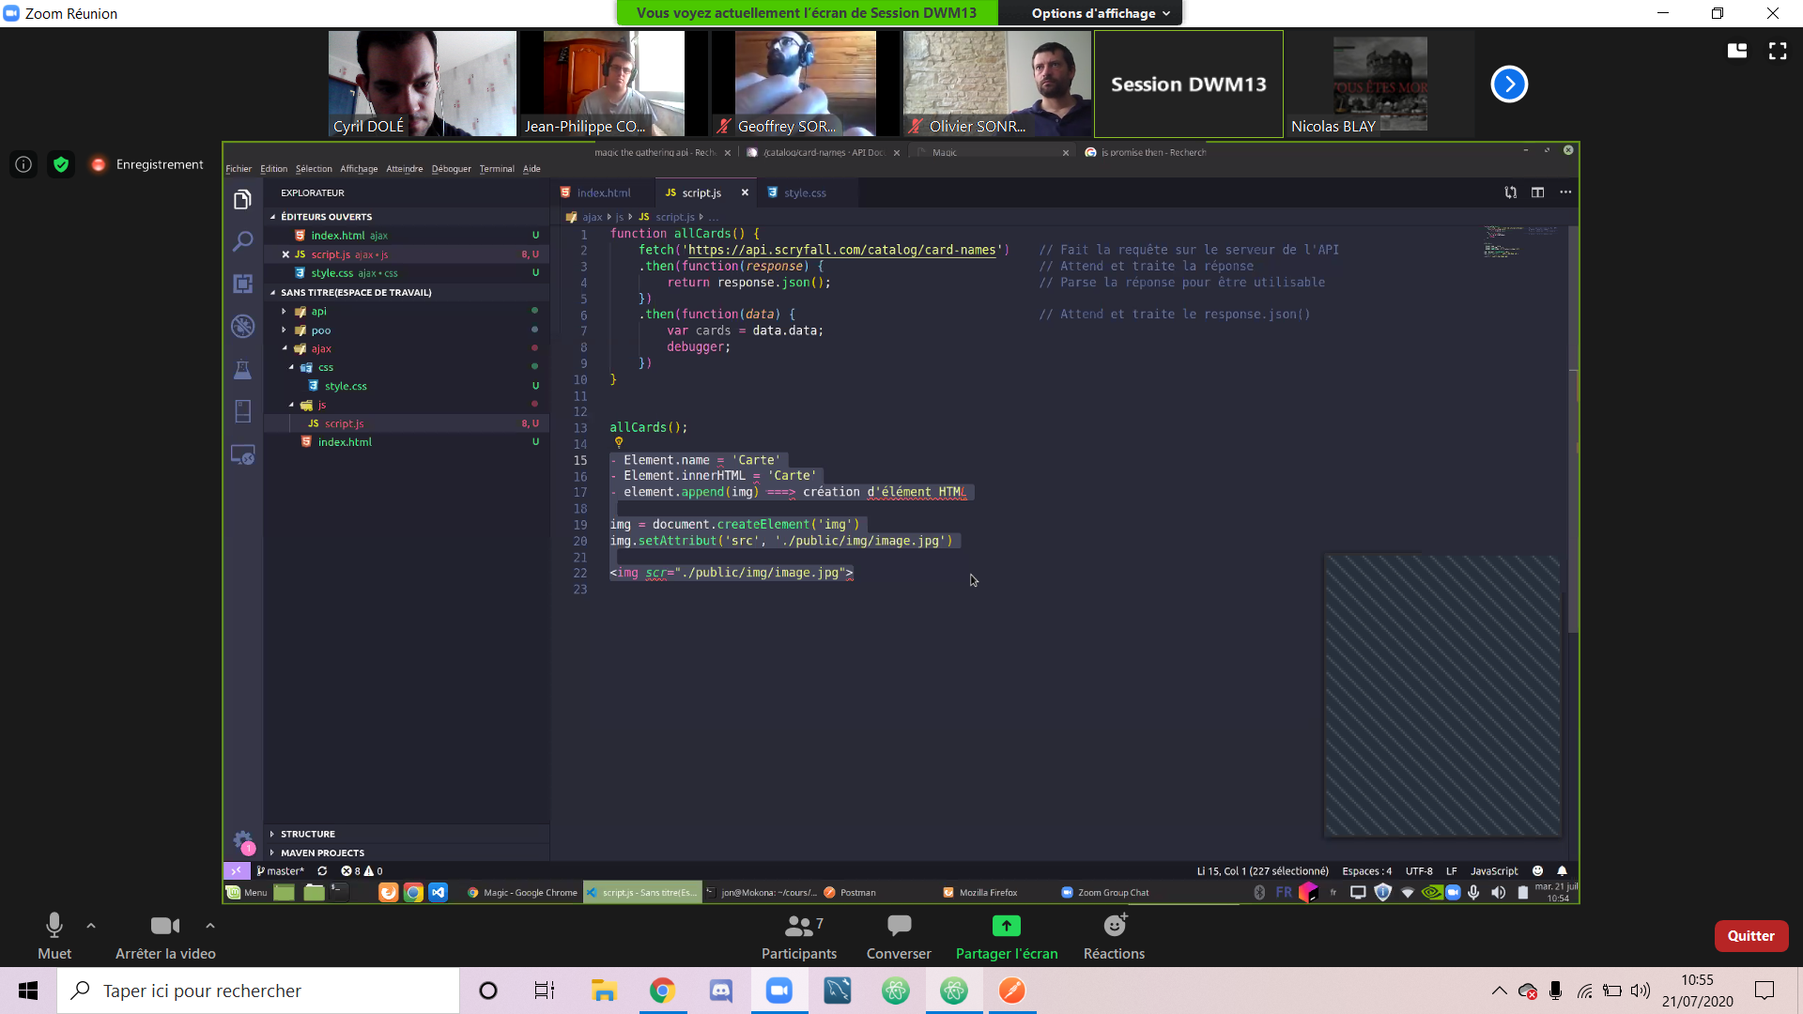

j.peraudon@it-akademy.fr